**Institute of computer technology**

**Ganpat university**

**B.tech. CSE (CBA/BDA/CS)**

**(2CSE301) DATABASE MANAGEMENT SYSTEM**

# PRACTICAL 14 (Stored Function)

1. Create a function findmax() which returns max number from given two number.

delimiter //

create function findmax_and_store (num1 int , num2 int )

returns int

deterministic

no sql

begin

declare max_num int ;

if num1> num2 then

set max_num = num1;

else

set max_num = num2;

end if ;

RETURN max_num;

end;

//

set @result1 = findmax_and_store(10, 20);

select @result1;

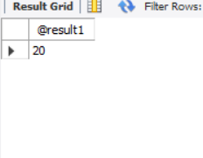

1. Create a function findgrade() Calculate grade based on marks and returns grade.

|  |  |
| --- | --- |
| **Marks** | **Grade** |
| Marks>=90 | A+ |
| Marks<90 and Marks>=80 | A |
| Marks <80 and Marks >=70 | B+ |
| Marks <70 and Marks >=60 | B |
| Marks <60 and Marks >=50 | C+ |
| Marks<50 and Marks >=40 | C |
| Marks<40 | F |
|  |  |

delimiter //

create function findgrade(marks int )

returns varchar (2)

deterministic

no sql

begin

declare grade varchar (2);

if makrs >= 90 then

set grade = 'A+';

else if marks >= 80 then

set grade = 'A';

elseif marks >= 70 then

set grade = 'B+';

elseif marks >= 60 then

set grade = 'B';

elseif marks >= 50 then

set grade = 'C+';

elseif marks >= 40 then

set grade = 'C';

else

set grade = 'F';

end if ;

return grade;

end;

delimiter ;

set @result2 = findgrade(90);

select @result2;

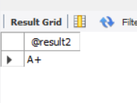

1. Create function which returns Percentage of student from student table based on rollno.

delimiter //

create function getStudentPercentage(roll_no int)

returns decimal (5,2)

deterministic

reads sql data

begin

declare percentage decimal(5,2);

select marks_obtained / total_marks * 100

into percentage

from student

where student_rollno = roll_no;

return percentage;

end;

//

delimiter ;

drop function getStudentPercentage;

set @result3 = getStudentPercentage(3);

select @result3;

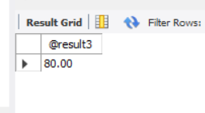

1. Create function which returns number of student from student table based on branch.

delimiter //

create function countStudentByBranch(branch_name varchar(100))

returns int

deterministic

reads sql data

begin

declare student_count int ;

select count(*) into student_count

from student

where branch = branch_name;

return student_count;

end;

//

delimiter ;

set @result4 = countStudentByBranch('cs');

select @result4;

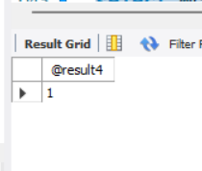

1. Create a function that returns yesterday's date.

DELIMITER //

CREATE FUNCTION getYesterdayDate()

RETURNS DATE

DETERMINISTIC

NO SQL

BEGIN

RETURN DATE_SUB(CURDATE(), INTERVAL 1 DAY);

END;

//

DELIMITER ;

SET @result5 = getYesterdayDate();

SELECT @result5;

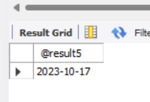

1. Create a function that returns tommorrow's date.

DELIMITER //

CREATE FUNCTION getTomorrowDate()

RETURNS DATE

DETERMINISTIC

NO SQL

BEGIN

RETURN DATE_ADD(CURDATE(), INTERVAL 1 DAY);

END;

//

DELIMITER ;

SET @result6 = getTomorrowDate();

SELECT @result6;

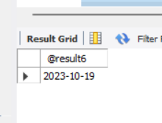

1. Create a function that Calculate number of days between two date and returns it .

DELIMITER //

CREATE FUNCTION calculateDaysBetweenDates(date1 DATE, date2 DATE)

RETURNS INT

DETERMINISTIC

NO SQL

BEGIN

RETURN DATEDIFF(date1, date2);

END;

//

DELIMITER ;

SET @result7 =calculateDaysBetweenDates('2023-10-10', '2023-10-1');

SELECT @result7;

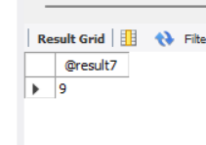

1. Create a function that Calculate number of days between today and your birthdate returns it.

DELIMITER //

CREATE FUNCTION calculateDaysToBirthday(birthdate DATE)

RETURNS INT

DETERMINISTIC

NO SQL

BEGIN

RETURN DATEDIFF(birthdate, CURDATE());

END;

//

DELIMITER ;

SET @result8 =calculateDaysToBirthday('2024-10-03');

SELECT @result8;

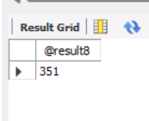

1. Create a function that Calculate Age From Date Of Birth and returns age.

DELIMITER //

CREATE FUNCTION calculateAgeFromDateOfBirth(birthdate DATE)

RETURNS INT

DETERMINISTIC

NO SQL

BEGIN

RETURN YEAR(CURDATE()) - YEAR(birthdate) - (DATE_FORMAT(CURDATE(),

'%m%d') < DATE_FORMAT(birthdate, '%m%d'));

END;

//

DELIMITER ;

SET @result9 =calculateAgeFromDateOfBirth('2004-10-03');

SELECT @result9;

